

Internal Rules

Procedure for the Development and Modification of Study Programmes at Riga Technical College

Riga

26.07.2024. Nr. 1.1.-2/12

Approved

Riga Technical College 26.07.2024.

at the meeting of the Council (Minutes No.3-2024)

Issued in accordance with the Law on the State Administration System

Section 72 (1) (2)

and Section 55 (3) of the Law on Higher Education

1. **General rules**
2. The Internal Regulations "Procedure for Developing and Changing Study Programmes at Riga Technical College" (hereinafter - the Regulations) establish the procedure for initiating, developing, evaluating, approving and changing study programmes at Riga Technical College (hereinafter - the College).
3. The programme of study shall include all the requirements for the award of a short-cycle vocational higher education qualification and a level 5 professional qualification leading to a short-cycle vocational higher education diploma.

**II. Developing new study programmes**

1. The development of a new study programme may be initiated by the head of a department/division, teaching staff, employers or partner universities of the college (hereinafter − the initiator) by submitting an application to the Deputy Director of the college in the field of quality and development of education, stating:

3.1. the rationale for the study programme;

3.2. the professional qualification;

3.3. the aims and objectives of the study programme;

3.4. the field of study to which the study programme will correspond;

3.5. a study of the supply of higher education at the appropriate level in Latvia and abroad;

3.6. an analysis of opportunities for cooperation with other study programmes, higher education institutions and other institutions;

3.7. the possible sources of funding for the establishment and implementation of the study programme.

1. The Vice Principal for Educational Quality and Development shall assess the relevance and appropriateness of the proposal in accordance with the College's policy planning documents and take a decision on whether to proceed to the College Council for approval or rejection.
2. The Vice Principal for Educational Quality and Development shall assess the relevance and appropriateness of the proposal in accordance with the College's policy planning documents and take a decision on whether to proceed to the College Council for approval or to reject the proposal.
3. After the decision of the College Council on the development of a new study programme has been adopted, the head of the relevant department, with the involvement of the proposer, shall organise the development of the programme and its course descriptions in accordance with external normative acts, taking into account the guidelines published on the website of the Foundation ‘Academic Information Centre’[1].
4. Study programmes shall be developed in accordance with these Regulations, applicable external normative acts and the Occupational Standard, which defines the knowledge, skills and competences appropriate for obtaining a professional qualification, taking into account the guidelines published on the website of the Foundation "Academic Information Centre", in compliance with the uniform requirements of the College set out in the Annexes to these Regulations:
   1. Schedule of the study process (2.5 years − full-time studies) /Annex No.1/;

7.2. Schedule of the study process (2 years − full-time studies) /Annex 2/;

7.3. Study plan with credits (2.5 years − full-time studies) /Annex 3/;

7.4. Study plan with credits (2 years − full-time) /Annex 4/;

7.5. Contact hours breakdown (2.5 years − full-time studies) /Annex 5/;

7.6. Breakdown of contact hours (2 years − full-time) /Annex 6/.

1. The curriculum is evaluated by the Deputy Director for Studies and Education and submitted to the College Council for consideration.
2. The decision on approval and submission of a study programme for licensing shall be taken by the College Council.
3. After receiving a licence to implement a study programme, the Director of the College appoints the Director of the established study programme.
4. **Development, updating and modification of course descriptions**
5. The course descriptions of the study programmes shall be developed in accordance with these Regulations, applicable external normative acts and the Occupational Standard, which defines the knowledge, skills and competences appropriate for obtaining a professional qualification, taking into account the guidelines published on the website of the Foundation ‘Academic Information Centre’, in compliance with the uniform requirements of the College, as set out in the Annexes to these Regulations:
   1. RTC course of study. Name, code of the study programme / Annex 7/;
   2. Study course calendar / Annex Nr.8/;
   3. Structure of the Study Course /Annex 9/.
6. The course description shall be developed by the course faculty member in collaboration with the study programme director and submitted to the head of the department.
7. The Head of the Department shall evaluate the course description and submit it to the Deputy Director for Studies and Education for approval.
8. Updating of the content and changes in study courses may be initiated by the study programme director, academic staff involved in programme implementation, students and representatives of employers by submitting a motivated application to the deputy director of the college in the field of studies and education.
9. The Deputy Director for Studies and Education organises the updating of the study programme and its advancement to the College Council for approval, involving the proposer or his/her representatives. D
10. Existing courses of study in the study programme may be updated up to a maximum of twenty per cent of the total number of credits.
11. In the absence of a proposal as provided for in paragraph 13 of this Regulation, the curricula of courses of study shall be updated every two academic years, taking into account the experience gained during the conduct of the course of study, imported innovations, suggestions from students, as well as developments in the field and new technologies.
12. The study course shall be deemed to be included in the Study programme and shall be implemented after its approval.
13. **Concluding question**

19. Internal Regulation No.1.1.-2/25 of 05.12.2023 ‘Procedure for Development and Approval of Study Programmes’ and Internal Regulation No.1.1.-2/26 of 05.12.2023 ‘Procedure for Development and Update of Study Course Programmes’ shall be repealed.

Deputy Director for Studies and Education

E.Džeksone 67081414

Appendix No.1

26.07.2024. Internal Rules No.1.1.-2/12

“Procedure for the Development and Modification of Study Programmes at Riga Technical College”

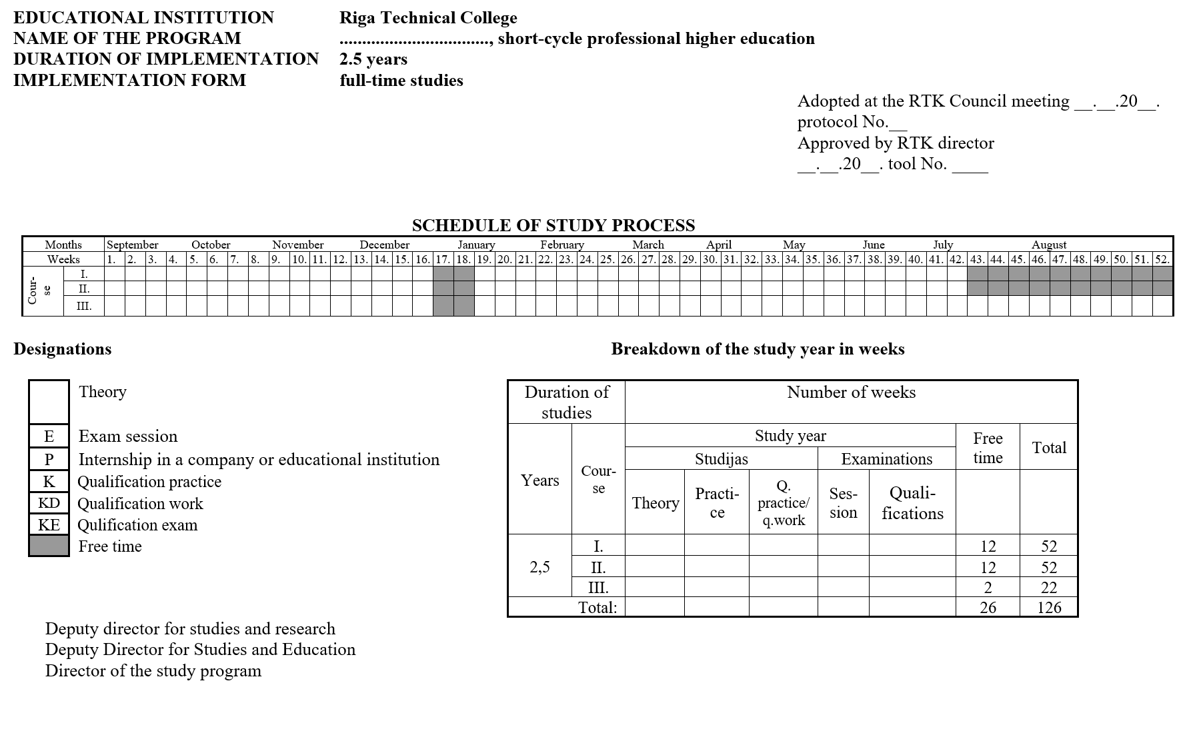

Appendix No.2

26.07.2024. Internal Rules No.1.1.-2/12

“Procedure for the Development and Modification of Study Programmes at Riga Technical College”

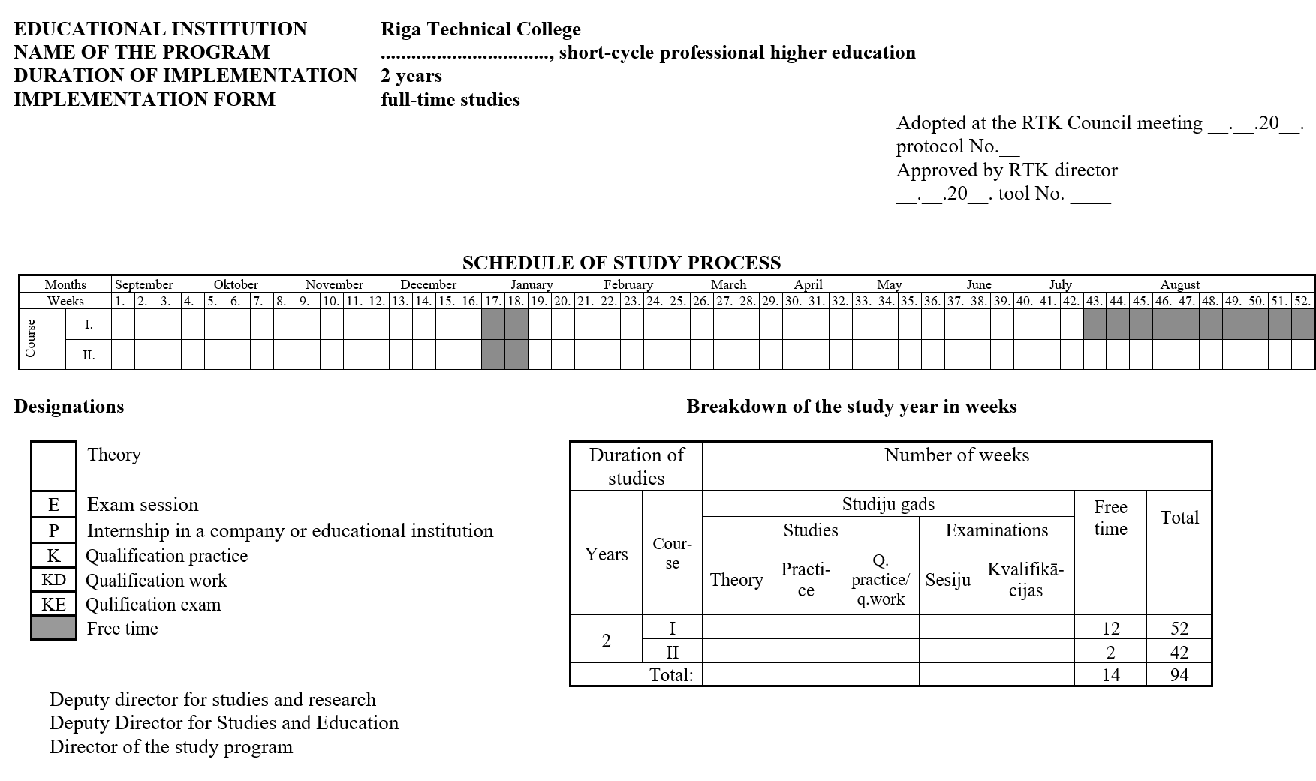

Appendix No.3

26.07.2024. Internal Rules No.1.1.-2/12

“Procedure for the Development and Modification of Study Programmes at Riga Technical College”

|  |  |  |  |  |  |  |  |  |  |  |  |  |
| --- | --- | --- | --- | --- | --- | --- | --- | --- | --- | --- | --- | --- |
| EDUCATIONAL INSTITUTION | | **Rīgas Tehniskā koledža** | | | | | |  |  |  |  | |
| PROGRAM NAME | | **__________________________________** | | | | | | |  |  |  | |
|  |  | short cycle professional higher education | | | | | | | | | | |
| DURATION OF IMPLEMENTATION | | **2,5 years** | |  |  |  |  |  |  |  |  | |
| INPLEMENTATION FORM | | **full-time studies** | | |  |  |  |  |  |  |  | |
|  |  |  |  |  |  |  |  |  |  |  |  | |
| No. | Study coursies | Test withaout a grade | Test with a grade | Course work (semester) | Examinations (semester) | Total number of credit points | CP | CP | CP | CP | CP | |
| I.course | | II.course | | III.course | |
| I. sem. | II. sem. | III. sem. | IV. sem. | V. sem. | |
| **Compulsory general education study coursies** | |  |  |  |  |  |  |  |  |  |  | |
| 1. |  |  |  |  |  |  |  |  |  |  |  | |
| 2. |  |  |  |  |  |  |  |  |  |  |  | |
| 3. |  |  |  |  |  |  |  |  |  |  |  | |
| 4. |  |  |  |  |  |  |  |  |  |  |  | |
| 5. |  |  |  |  |  |  |  |  |  |  |  | |
| 6. |  |  |  |  |  |  |  |  |  |  |  | |
| 7. |  |  |  |  |  |  |  |  |  |  |  | |
| **Total:** | |  |  |  |  |  |  |  |  |  |  | |
| **Compulsory professional study courses** | |  |  |  |  |  |  |  |  |  |  | |
| 8. |  |  |  |  |  |  |  |  |  |  |  | |
| 9. |  |  |  |  |  |  |  |  |  |  |  | |
| 10. |  |  |  |  |  |  |  |  |  |  |  | |
| 11. |  |  |  |  |  |  |  |  |  |  |  | |
| 12. |  |  |  |  |  |  |  |  |  |  |  | |
| 13. |  |  |  |  |  |  |  |  |  |  |  | |
| 14. |  |  |  |  |  |  |  |  |  |  |  | |
| 15. |  |  |  |  |  |  |  |  |  |  |  | |
| 16. |  |  |  |  |  |  |  |  |  |  |  | |
| 17. |  |  |  |  |  |  |  |  |  |  |  | |
| 18. |  |  |  |  |  |  |  |  |  |  |  | |
| 19. |  |  |  |  |  |  |  |  |  |  |  | |
| 20. |  |  |  |  |  |  |  |  |  |  |  | |
| 21. |  |  |  |  |  |  |  |  |  |  |  | |
| 22. |  |  |  |  |  |  |  |  |  |  |  | |
| **Total:** | |  |  |  |  |  |  |  |  |  |  | |
| **Limited optional study courses study coursies\*** | |  |  |  |  |  |  |  |  |  |  | |
| 23. |  |  |  |  |  |  |  |  |  |  |  | |
| 24. |  |  |  |  |  |  |  |  |  |  |  | |
| 25. |  |  |  |  |  |  |  |  |  |  |  | |
| 26. |  |  |  |  |  |  |  |  |  |  |  | |
| **Optional study course\*\*** | |  |  |  |  |  |  |  |  |  |  | |
| 27. | Optional study coure |  |  |  |  |  |  |  |  |  |  | |
| **Total:** | |  |  |  |  |  |  |  |  |  |  | |
|  |  |  |  |  |  |  |  |  |  |  |  | |
| **Internships** | |  |  |  |  |  |  |  |  |  |  | |
| 28 | Practice |  |  |  |  |  |  |  |  |  |  | |
| 29. | Qualification practice |  |  |  |  |  |  |  |  |  |  | |
|  | **Total:** |  |  |  |  |  |  |  |  |  |  | |
| **Qualification thesis** | |  |  |  |  |  |  |  |  |  |  | |
| **Total:** | |  |  |  |  |  |  |  |  |  |  | |
|  |  |  |  |  |  |  |  |  |  |  |  | |
| One credit point (CP) corresponds to 26 hours of student work, i.e. 13 contact hours and 13 hours of independent work. | | | | | | | | | | |  |
| In practice, learners have 40 hours a week. | |  |  |  |  |  |  |  |  |  |  | |
| * need to get ___KP | |  |  |  |  |  |  |  |  |  |  | |
| ** need to get ___KP | |  |  |  |  |  |  |  |  |  |  | |

Appendix No.4

26.07.2024. Internal Rules No.1.1.-2/12

“Procedure for the Development and Modification of Study Programmes at Riga Technical College”

|  |  |  |  |  |  |  |  |  |  |  |
| --- | --- | --- | --- | --- | --- | --- | --- | --- | --- | --- |
| EDUCATIONAL INSTITUTION | | **Rīgas Tehniskā koledža** | | | | | |  |  |  |
| PROGRAM NAME | | **__________________________________** | | | | | | |  |  |
|  |  | short cycle professional higher education | | | | | | | | |
| DURATION OF IMPLEMENTATION | | **2 years** | |  |  |  |  |  |  |  |
| INPLEMENTATION FORM | | **full-time studies** | | |  |  |  |  |  |  |
|  |  |  |  |  |  |  |  |  |  |  |
| No. | Study coursies | Test  withaout a grade | Test  with a grade | Course work (semester) | Examinations (semester) | Total number of credit points | CP | CP | CP | CP |
| I.course | | II.course | |
| I. sem. | II. sem. | III. sem. | IV. sem. |
| **Compulsory general education study coursies** | |  |  |  |  |  |  |  |  |  |
| 1. |  |  |  |  |  |  |  |  |  |  |
| 2. |  |  |  |  |  |  |  |  |  |  |
| 3. |  |  |  |  |  |  |  |  |  |  |
| 4. |  |  |  |  |  |  |  |  |  |  |
| 5. |  |  |  |  |  |  |  |  |  |  |
| 6. |  |  |  |  |  |  |  |  |  |  |
| 7. |  |  |  |  |  |  |  |  |  |  |
| **Total:** | |  |  |  |  |  |  |  |  |  |
| **Compulsory professional study courses** | |  |  |  |  |  |  |  |  |  |
| 8. |  |  |  |  |  |  |  |  |  |  |
| 9. |  |  |  |  |  |  |  |  |  |  |
| 10. |  |  |  |  |  |  |  |  |  |  |
| 11. |  |  |  |  |  |  |  |  |  |  |
| 12. |  |  |  |  |  |  |  |  |  |  |
| 13. |  |  |  |  |  |  |  |  |  |  |
| 14. |  |  |  |  |  |  |  |  |  |  |
| 15. |  |  |  |  |  |  |  |  |  |  |
| 16. |  |  |  |  |  |  |  |  |  |  |
| 17. |  |  |  |  |  |  |  |  |  |  |
| 18. |  |  |  |  |  |  |  |  |  |  |
| 19. |  |  |  |  |  |  |  |  |  |  |
| 20. |  |  |  |  |  |  |  |  |  |  |
| 21. |  |  |  |  |  |  |  |  |  |  |
| 22. |  |  |  |  |  |  |  |  |  |  |
| **Total:** | |  |  |  |  |  |  |  |  |  |
| **Limited optional study courses study coursies\*** | |  |  |  |  |  |  |  |  |  |
| 23. |  |  |  |  |  |  |  |  |  |  |
| 24. |  |  |  |  |  |  |  |  |  |  |
| 25. |  |  |  |  |  |  |  |  |  |  |
| 26. |  |  |  |  |  |  |  |  |  |  |
| **Optional study course\*\*** | |  |  |  |  |  |  |  |  |  |
| 27. | Optional study coure |  |  |  |  |  |  |  |  |  |
| **Total:** | |  |  |  |  |  |  |  |  |  |
|  |  |  |  |  |  |  |  |  |  |  |
| **Internships** | |  |  |  |  |  |  |  |  |  |
| 28 | Practice |  |  |  |  |  |  |  |  |  |
| 29. | Qualification practice |  |  |  |  |  |  |  |  |  |
|  | **Total:** |  |  |  |  |  |  |  |  |  |
| **Qualification thesis** | |  |  |  |  |  |  |  |  |  |
| **Total:** | |  |  |  |  |  |  |  |  |  |
|  |  |  |  |  |  |  |  |  |  |  |
| One credit corresponds to 26 hours of work, i.e. 13 contact hours and 13 hours of independent work. | | | | | | | | |  |  |
| Students have 40 hours of internship per week. | |  |  |  |  |  |  |  |  |  |
| * __ credits are required from limited optional study courses | | | |  |  |  |  |  |  |  |
| ** __ credit is required from optional study courses | | |  |  |  |  |  |  |  |  |

Appendix No.5

26.07.2024. Internal Rules No.1.1.-2/12

“Procedure for the Development and Modification of Study Programmes at Riga Technical College”

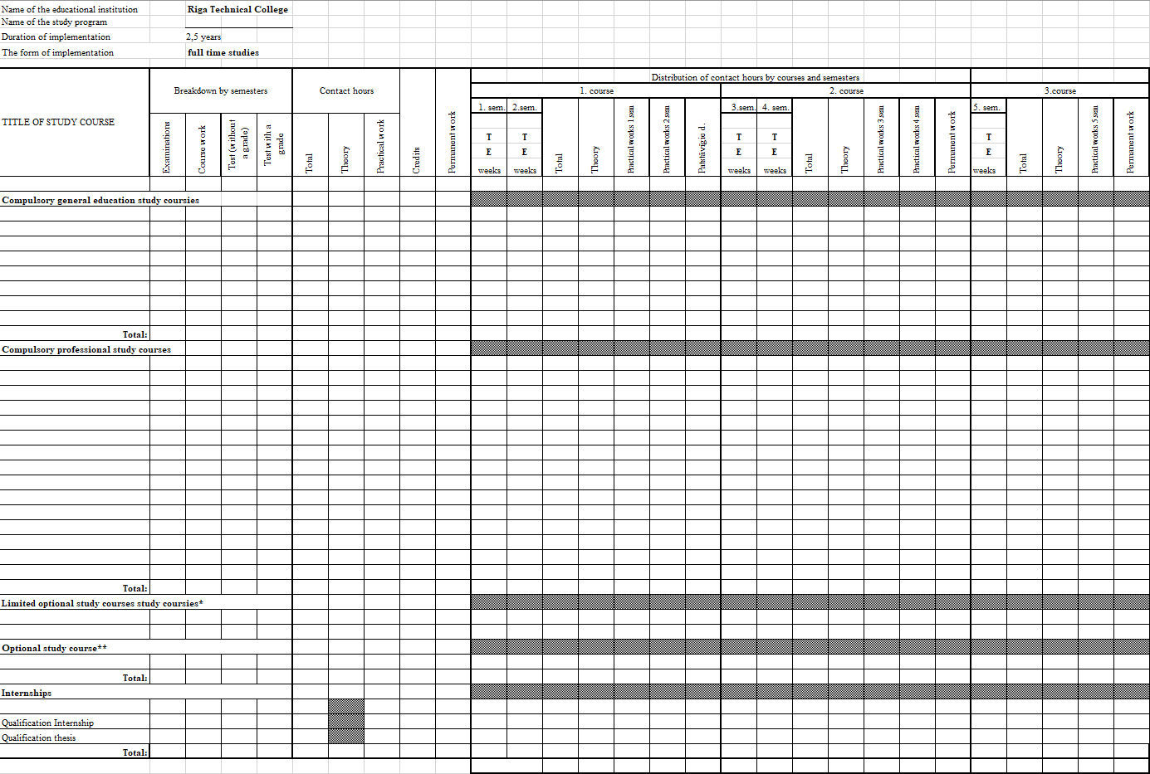

Appendix No.6

26.07.2024. Internal Rules No.1.1.-2/12

“Procedure for the Development and Modification of Study Programmes at Riga Technical College”

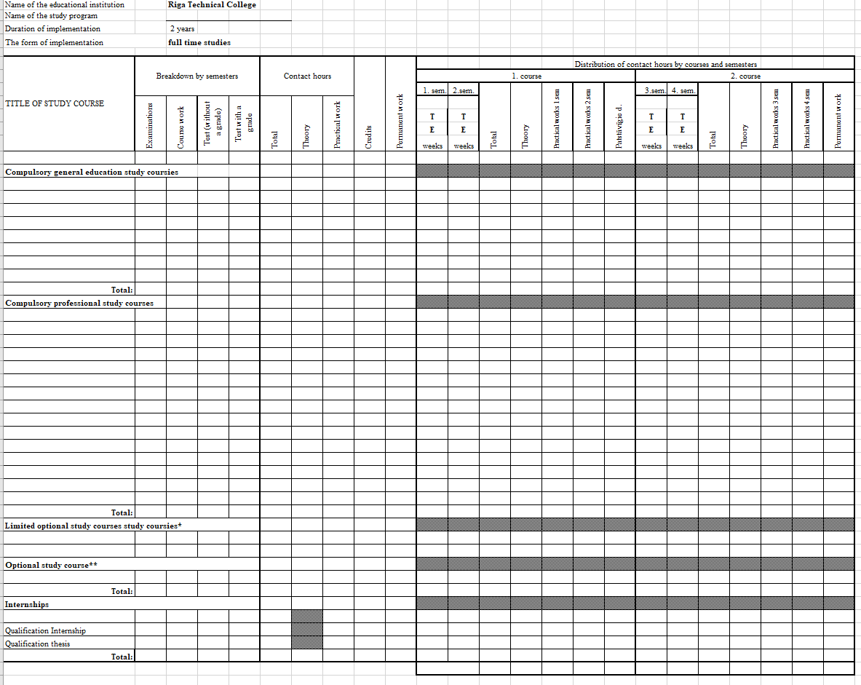

Appendix No.7

26.07.2024. Internal Rules No.1.1.-2/12

“Procedure for the Development and Modification of Study Programmes at Riga Technical College”

**RTC study course description**

|  |  |
| --- | --- |
| Name of the study programme, code |  |
| Name of the course |  |
| Teaching staff responsible |  |
| Teaching staff |  |
| Amount in parts and credits |  |
| Language of the course |  |
| Type of the study course |  |
| Goal and objectives, in terms of competences and skills |  |
| Learning outcomes |  |
| Independent work, its organisation and tasks |  |
| Criteria for assessing learning outcomes |  |
| Resources |  |
| Previous knowledge required |  |

Appendix No.8

26.07.2024. Internal Rules No.1.1.-2/12

“Procedure for the Development and Modification of Study Programmes at Riga Technical College”

**Study course calendar**

|  |  |  |  |  |
| --- | --- | --- | --- | --- |
| No | **Topic of the lesson** | **Type of the lesson**  (lectures, practical classes) | | **Amount of lessons** |
| **First semester** | | | | |
| 1. |  |  | |  |
|  |  | |  |
|  | |  |
| 2. |  | | | |
|  |  | |  |
|  | |  |
| 3. |  | | | |
|  |  | |  |
|  | |  |
| 4. |  | | | |
|  |  | |  |
|  | |  |
| Type of test | | |  | |
|  | | **Total:** | |  |
| **Second semester** | | | | |
| 5. |  |  | |  |
| 6. |  |  | |  |
| Type of test | | |  | |
|  | | **Total** | |  |

Appendix No.9

26.07.2024. Internal Rules No.1.1.-2/12

“Procedure for the Development and Modification of Study Programmes at Riga Technical College”

**Study course structure**

|  |  |  |  |  |  |  |
| --- | --- | --- | --- | --- | --- | --- |
| **Semester** | **Credits** | **Lectures**  **(hours)** | **Practical work**  **(hours)** | **Independent work** **(hours)** | **Term paper** | **Type of test** |
|  |  |  |  |  |  |  |
|  |  |  |  |  |  |  |

Criteria for assessing learning outcomes:

1. <https://www.aika.lv/wp-content/uploads/2019/05/Vadlinijas-studiju-programmas-raksturojuma-izstradei_2019.pdf>